Solution Architecture
ShopEZ — MERN Stack E-commerce Application

Phase: Project Design Phase
TEAM ID : SWUID2026207177

Classification: Project Documentation — For Academic Submission
Solution Architecture
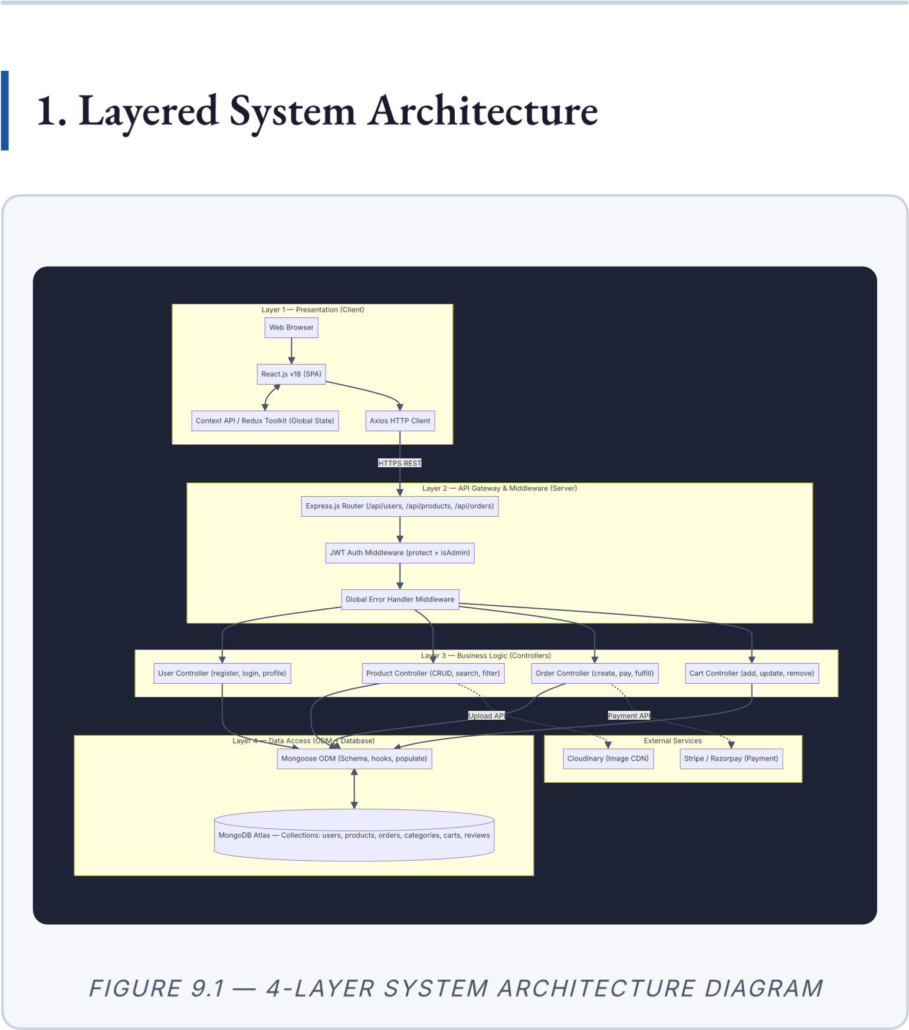
- MVC Pattern Mapping
MVC  Layer |  | MERN  Component | Responsibilities
 | View | React.js  (Frontend SPA) | Renders UI components; manages  local state; dispatches API calls via
Axios; updates global state via
Context/Redux
Controller |  | Express.js  Controllers | Receives validated HTTP requests; orchestrates business logic; invokes Model methods; formats and returns  JSON responses
 | Model | Mongoose  Schemas &  Models | Defines data structure, validation rules, and type constraints; executes lifecycle hooks; interfaces with
MongoDB Atlas

- UML Class Diagram — Mongoose Models
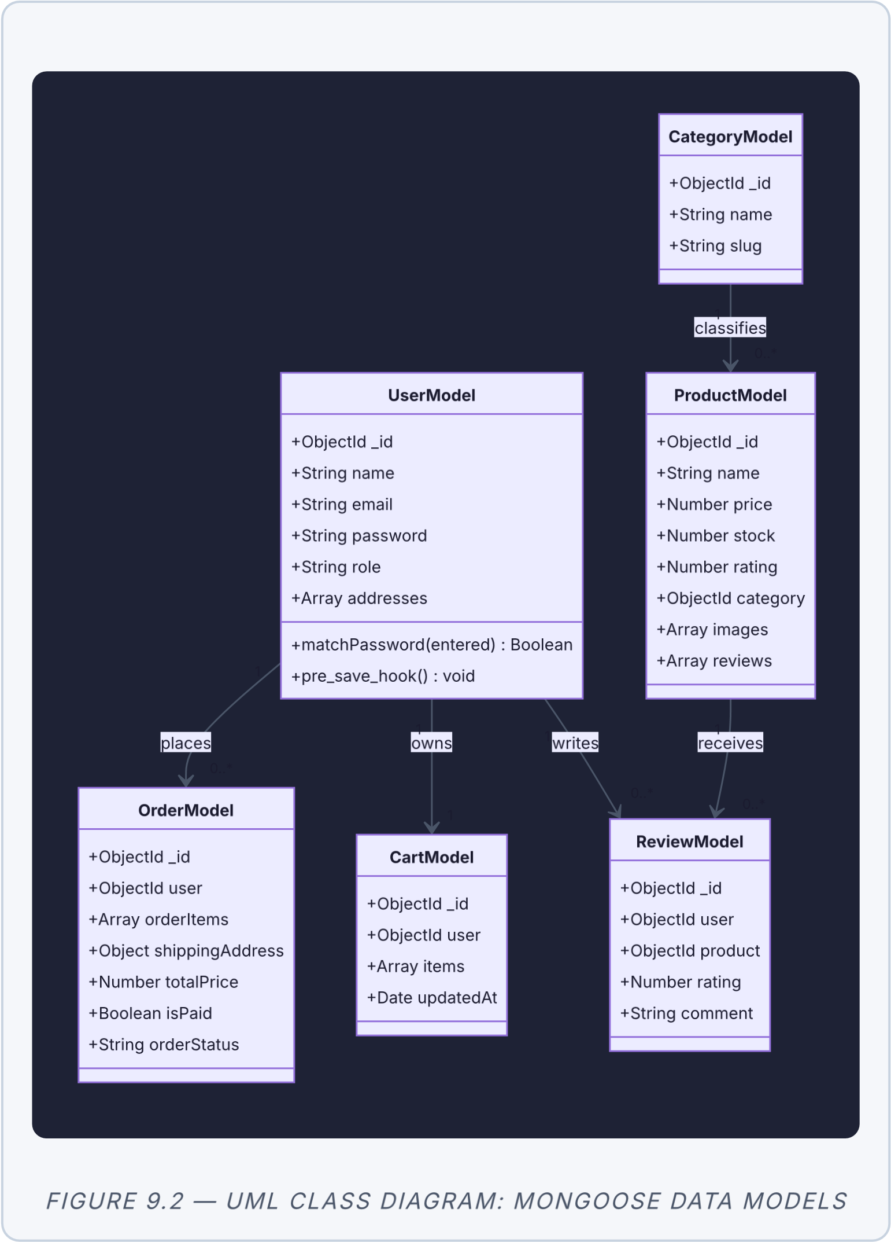
4
. Deployment Topology
HTTPS
API

Calls
(
HTTPS
+
CORS
)
TLS
/
Mongoose
REST

API
REST

API
🌍

End

User
(
Browser
)
☁

Vercel

CDN
(
React

SPA
—
static

files
)
🖥

Render
(
Node
.
js
/
Express

API
—
Port
8000)
🗄

MongoDB

Atlas
(
Cloud

Cluster
)
🖼

Cloudinary
(
Image

CDN
)
💳

Stripe
/
Razorpay
(
Payment

API
)
F
I
G
U
R
E

9
.
3

—

C
L
O
U
D

D
E
P
L
O
Y
M
E
N
T

T
O
P
O
L
O
G
Y
5
. Deployment URL Reference
Component | Platform | URL
Frontend
(
React

SPA
)
Vercel
https:
/
/e-commerce-
application-neon-
five.vercel.app/
Backend
(
Node
.
js

API
)
Render
https:
/
/shopez-api-
c30e.onrender.com
Database
MongoDB
Cloud
-
hosted
(
M
0

Free

Tier
)
Atlas
Image
Storage
Cloudinary
res.cloudinary.com/
//
.

ShopEZ MERN E-commerce Application · Project Design Phase · Solution Architecture

